**Name:** V Venkata Sri Prasad

**Batch:** Data Engineering

**Date:** 22/01/2024 – (Day 4)

**Topics: Clauses**

**Where Clauses:**

**Exists**

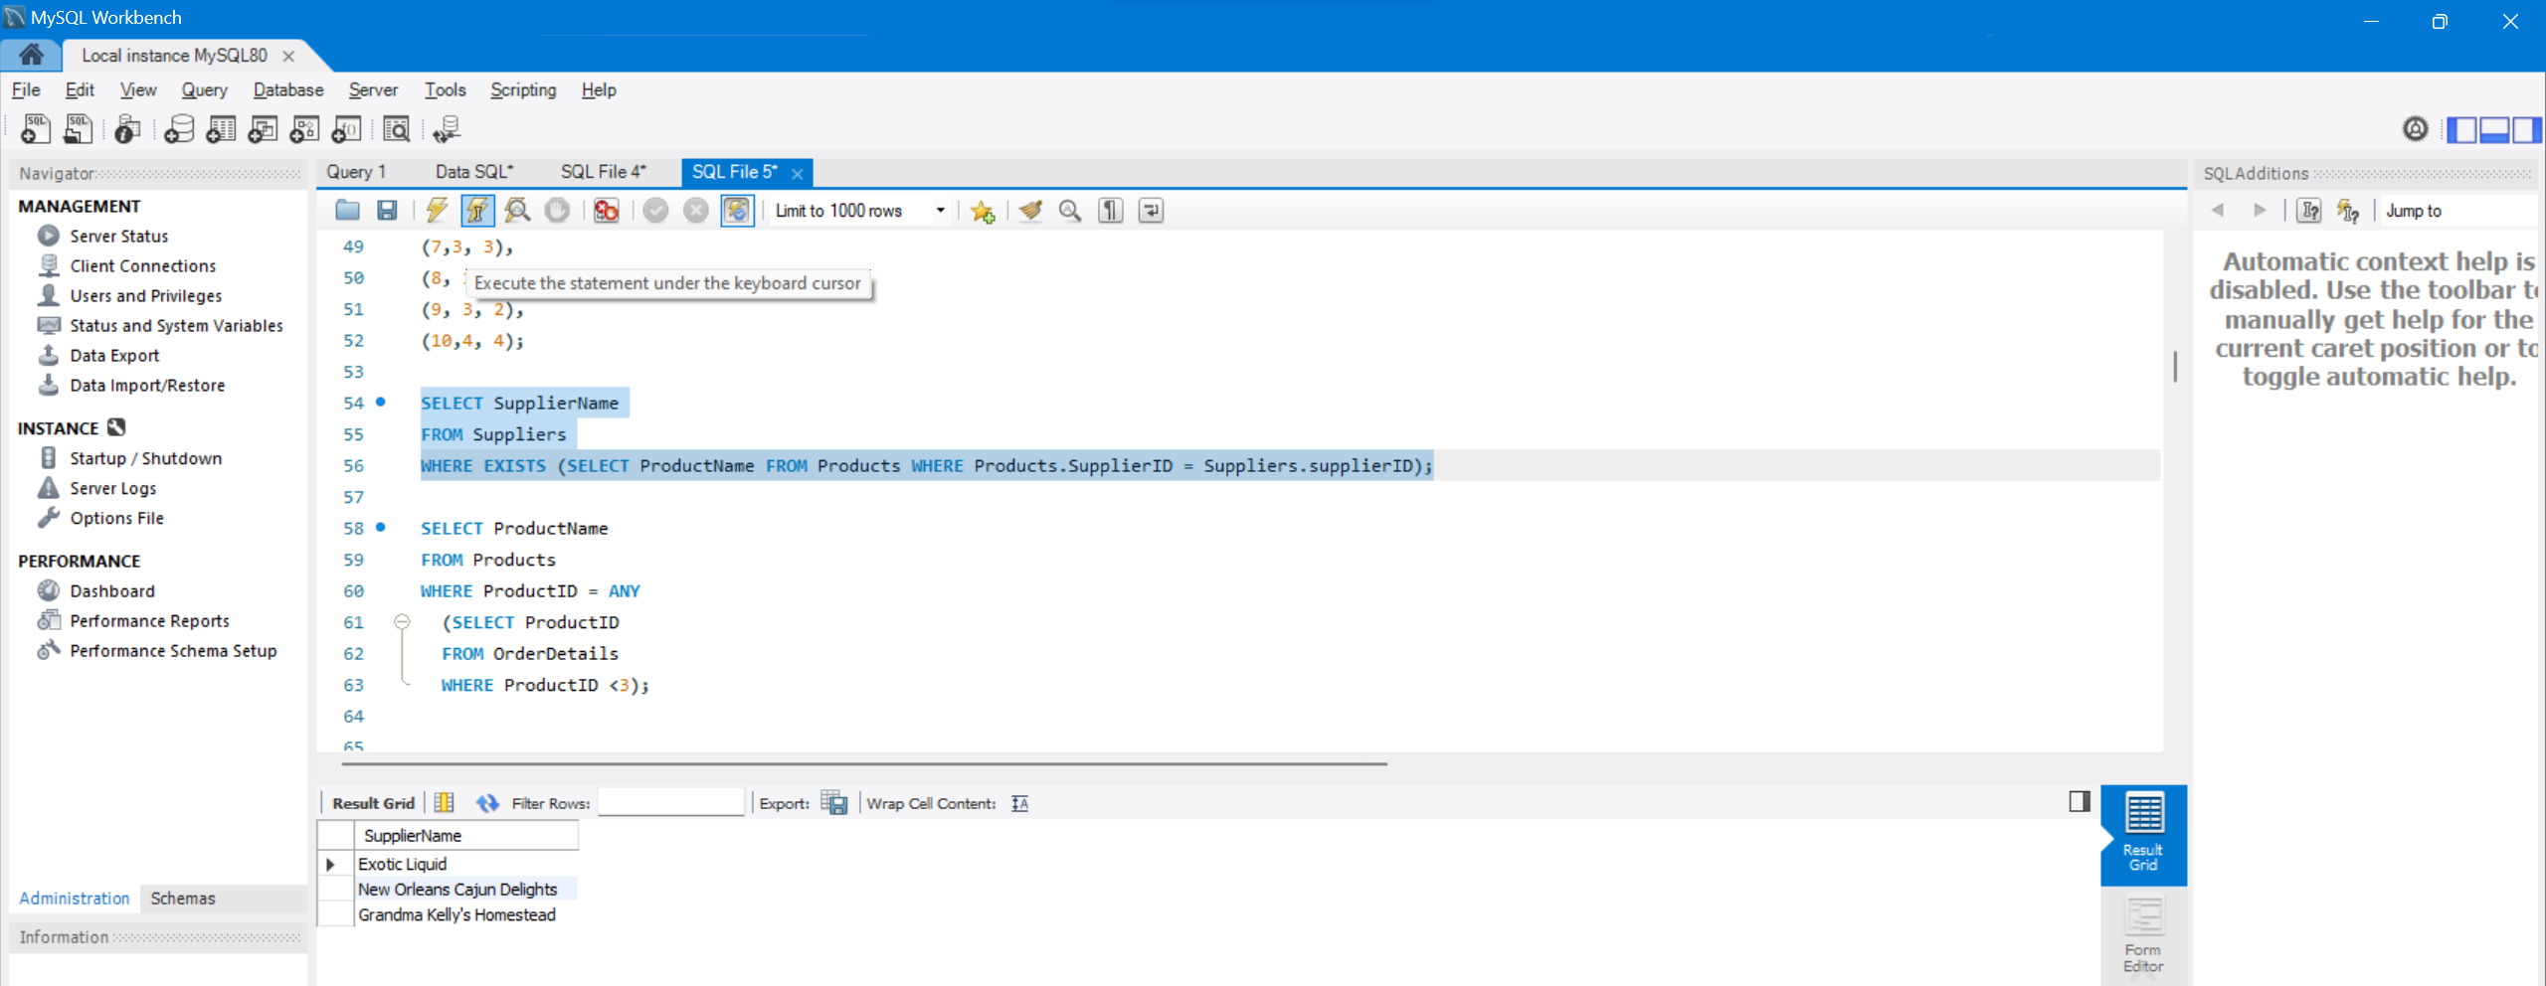

**Any**

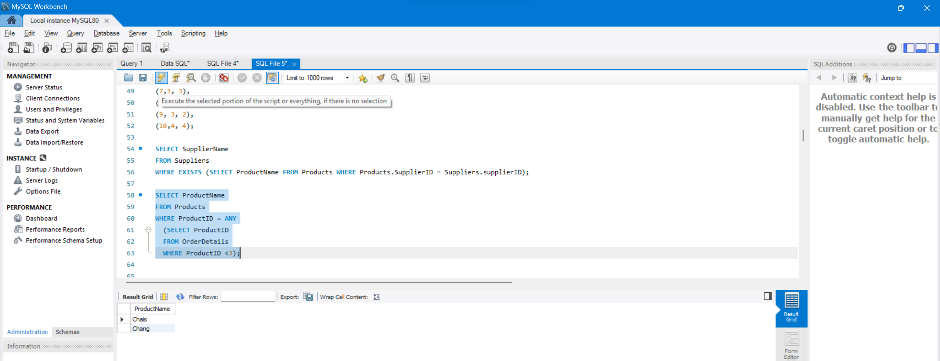

**ALL**

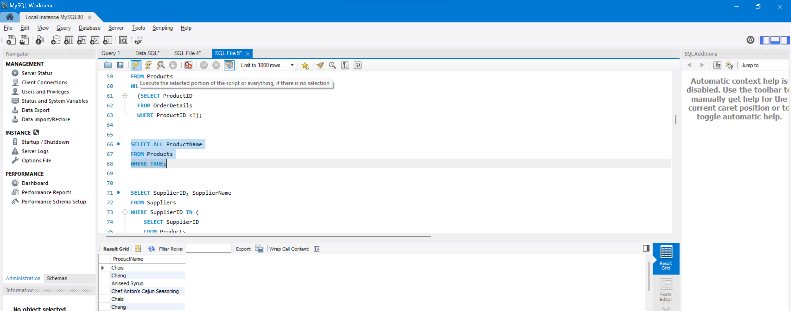

**Having Clauses:**

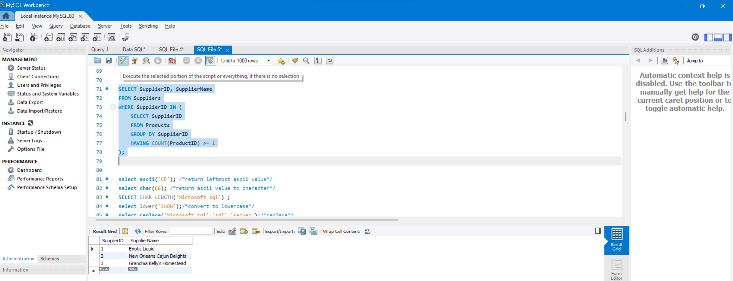

**String functions:**

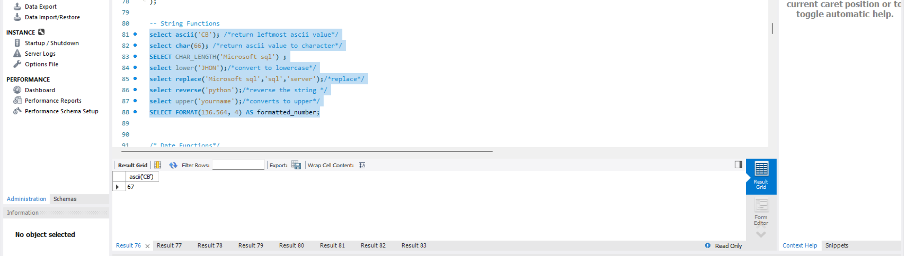

**Date Functions:**

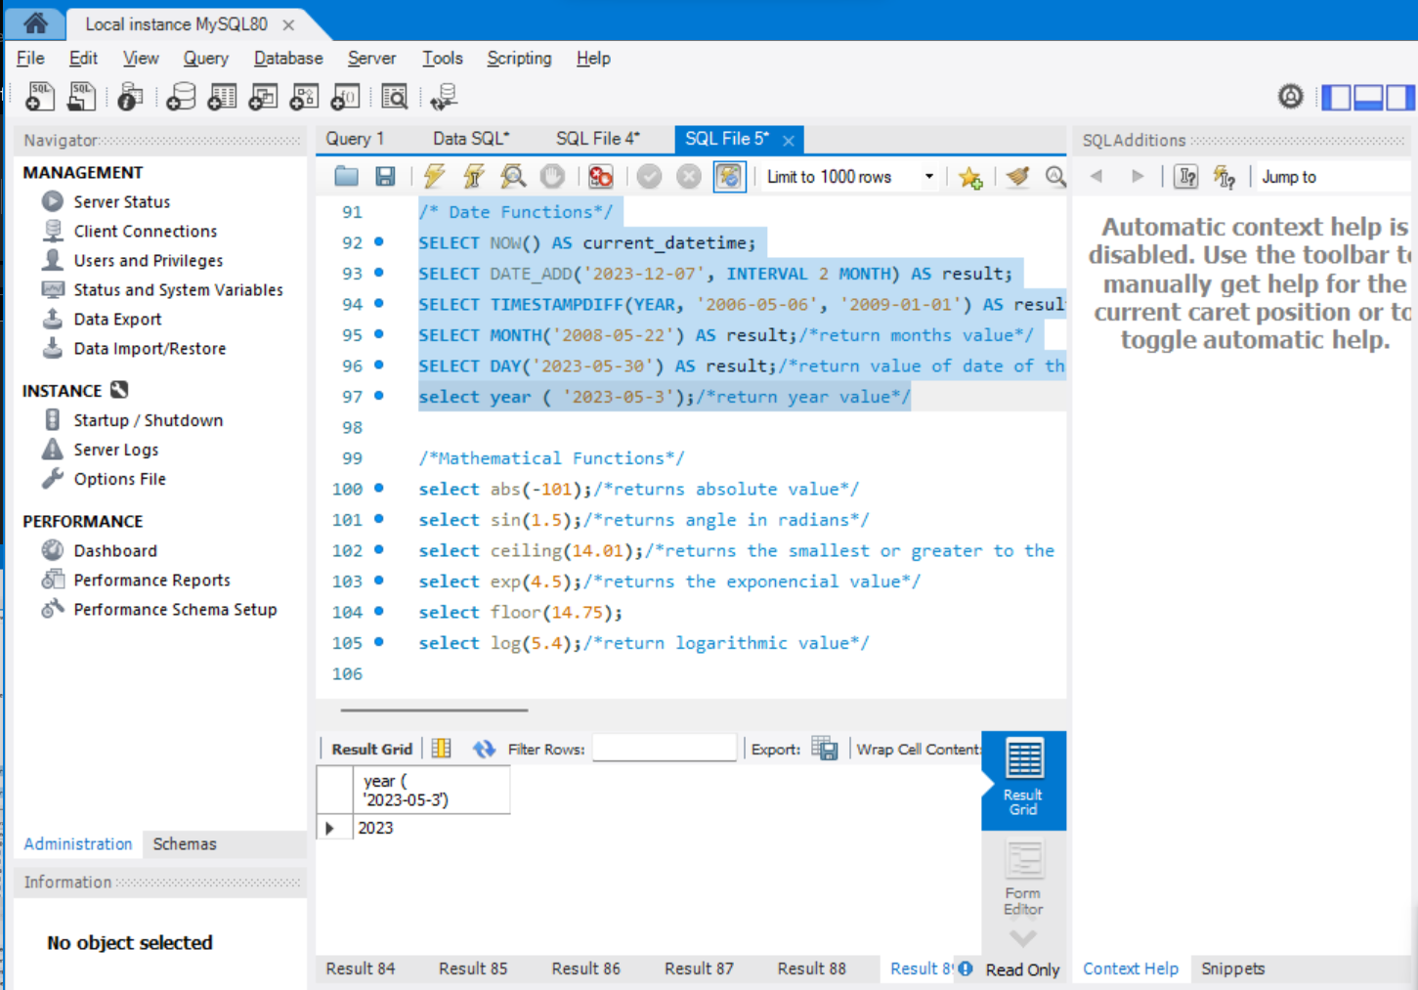

**Mathematical Functions**

